**Course:-Data Base Instructor:- Ali Samad**

**Class:-BSCS-3rd-Morning. Submission Date:-10-11-2011**

**Assignments:-**

## Assignment 1:- (convert the following description into ER-Diagram,Relational Model and by using the relational model create a database in SQL Server)

A publishing company produces scientific books on various subjects. The books are written by authors who specialize in one particular subject. The company employs editors who, not necessarily being specialists in a particular area, each take sole responsibility for editing one or more publications. A publication covers essentially one of the specialist subjects and is normally written by a single author. When writing a particular book, each author works with on editor, but may submit another work for publication to be supervised by other editors. To improve their competitiveness, the company tries to employ a variety of authors, more than one author being a specialist in a particular subject.

## Assignment 2:- (convert the following description into ER-Diagram,Relational Model and by using the relational model create a database in SQL Server)

A General Hospital consists of a number of specialized wards (such as Maternity, Paediatry, Oncology, etc). Each ward hosts a number of patients, who were admitted on the recommendation of their own GP and confirmed by a consultant employed by the Hospital. On admission, the personal details of every patient are recorded. A separate register is to be held to store the information of the tests undertaken and the results of a prescribed treatment. A number of tests may be conducted for each patient. Each patient is assigned to one leading consultant but may be examined by another doctor, if required. Doctors are specialists in some branch of medicine and may be leading consultants for a number of patients, not necessarily from the same ward.

## Assignment 3:- (convert the following description into ER-Diagram,Relational Model and by using the relational model create a database in SQL Server)

A database is to be designed for a Car Rental Co. (CRC). The information required includes a description of cars, subcontractors (i.e. garages), company expenditures, company revenues and customers. Cars are to be described by such data as: make, model, year of production, engine size, fuel type, number of passengers, registration number, purchase price, purchase date, rent price and insurance details. It is the company policy not to keep any car for a period exceeding one year. All major repairs and maintenance are done by subcontractors (i.e. franchised garages), with whom CRC has long-term agreements. Therefore the data about garages to be kept in the database includes garage names, addressees, range of services and the like. Some garages require payments immediately after a repair has been made; with others CRC has made arrangements for credit facilities. Company expenditures are to be registered for all outgoings connected with purchases, repairs, maintenance, insurance etc. Similarly the cash inflow coming from all sources - car hire, car sales, insurance claims - must be kept of file.CRC maintains a reasonably stable client base. For this privileged category of customers special credit card facilities are provided. These customers may also book in advance a particular car. These reservations can be made for any period of time up to one month. Casual customers must pay a deposit for an estimated time of rental, unless they wish to pay by credit card. All major credit cards care accepted. Personal details (such as name, address, telephone number, driving licence, number) about each customer are kept in the database.

## Assignment 4:- (convert the following description into ER-Diagram,Relational Model and by using the relational model create a database in SQL Server)

A database is to be designed for a college to monitor students' progress throughout their course of study. The students are reading for a degree (such as BA, BA(Hons) MSc, etc) within the framework of the modular system. The college provides a number of module, each being characterised by its code , title, credit value, module leader, teaching staff and the department they come from. A module is co-ordinated by a module leader who shares teaching duties with one or more lecturers. A lecturer may teach (and be a module leader for) more than one module. Students are free to choose any module they wish but the following rules must be observed: some modules require pre-requisites modules and some degree programmes have compulsory modules. The database is also to contain some information about students including their numbers, names, addresses, degrees they read for, and their past performance (i.e. modules taken and examination results).

## Assignment 5:- (convert the following description into ER-Diagram,Relational Model and by using the relational model create a database in SQL Server)

A relational database is to be designed for a medium sized Company dealing with industrial applications of computers. The Company delivers various products to its customers ranging from a single application program through to complete installation of hardware with customized software. The Company employs various experts, consultants and supporting staff. All personnel are employed on long-term basis, i.e. there are no short-term or temporary staff. Although the Company is somehow structured for administrative purposes (that is, it is divided into departments headed by department managers) all projects are carried out in an inter-disciplinary way. For each project a project team is selected, grouping employees from different departments, and a Project Manager (also an employee of the Company) is appointed who is entirely and exclusively responsible for the control of the project, quite independently of the Company's hierarchy. The following is a brief statement of some facts and policies adopted by the Company.

## Assignment 6:- (convert the following ER-Diagram into Relational Model and by using the Relational model create a database in SQL Server)



**Assignment 7:- (Design an ER schema for this application, and draw an ER diagram for that schema. Specify key attributes of each entity type and structural constraints on each relationship type. Note any unspecified requirements, and make appropriate assumptions to make the specification complete,and implement in SQL Server**

## 

(a) The university keeps track of each student's name, student number, social security number, current address and phone, permanent address and phone, birthdate, gender, class (freshman, sophomore, ..., graduate), major department, minor department (if any), and degree program (B.A., B.S., ..., Ph.D.). Some user applications need to refer to the city, state, and zip of the student's permanent address, and to the student's last name. Both social security number and student number have unique values for each student.

(b) Each department is described by a name, department code, office number, office phone, and college. Both name and code have unique values for each department.

(c) Each course has a course name, description, course number, number of semester hours, level, and offering department. The value of course number is unique for each course.

(d) Each section has an instructor, semester, year, course, and section number. The section number distinguishes different sections of the same course that are taught during the same semester/year; its values are 1, 2, 3, ...; up to the number of sections taught during each semester.

(e) A grade report has a student, section, letter grade, and numeric grade (0, 1, 2, 3, 4 for F, D, C, B, A, respectively).

## Assignment 8:- (convert the following ER-Diagram into Relational Model and by using the Relational model create a database in SQL Server)

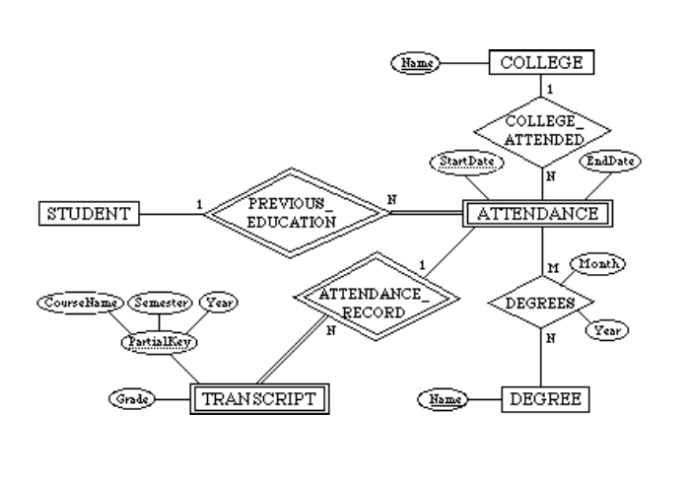  
**Assignment 9:- (Design an ER schema for this application, and draw an ER diagram for that schema. Specify key attributes of each entity type and structural constraints on each relationship type. Note any unspecified requirements, and make appropriate assumptions to make the specification complete, and implement in SQL Server.**

(1) The database represents each AIRPORT, keeping its unique AirportCode, the AIRPORT Name, and the City and State in which the AIRPORT is located.

(2) Each airline FLIGHT has a unique number, the Airline for the FLIGHT, and the Weekdays on which the FLIGHT is scheduled (for example, every day of the week except Sunday can be coded as X7).

(3) A FLIGHT is composed of one or more FLIGHT LEGs (for example, flight number CO1223 from New York to Los Angeles may have two FLIGHT LEGs: leg 1 from New York to Houston and leg 2 from Houston to Los Angeles). Each FLIGHT LEG has a DEPARTURE AIRPORT and Scheduled Departure Time, and an ARRIVAL AIRPORT and Scheduled Arrival Time.

(4) A LEG INSTANCE is an instance of a FLIGHT LEG on a specific Date (for example, CO1223 leg 1 on July 30, 1989). The actual Departure and Arrival AIRPORTs and Times are recorded for each flight leg after the flight leg has been concluded. The Number of available seats and the AIRPLANE used in the LEG INSTANCE are also kept.

(5) The customer RESERVATIONs on each LEG INSTANCE include the Customer Name, Phone, and Seat Number(s) for each reservation.

(6) Information on AIRPLANEs and AIRPLANE TYPEs are also kept. For each AIRPLANE TYPE (for example, DC-10), the TypeName, manufacturing Company, and Maximum Number of Seats are kept. The AIRPORTs in which planes of this type CAN LAND are kept in the database. For each AIRPLANE, the AirplaneId, Total number of seats, and TYPE are kept.

## Assignment 10:- (convert the following ER-Diagram into Relational Model and by using the Relational model create a database in SQL Server)

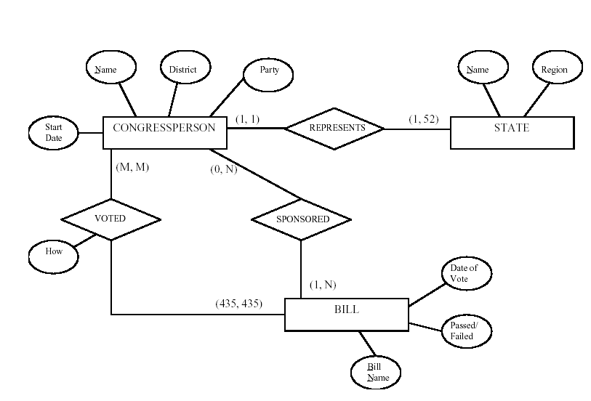

**Assignment 11:- (Design an ER schema for this application, and draw an ER diagram for that schema. Specify key attributes of each entity type and structural constraints on each relationship type. Note any unspecified requirements, and make appropriate assumptions to make the specification complete, and implement in SQL Server**

(a) A database is being constructed to keep track of the teams and games of a sports league. A team has a number of players, not all of whom participate in each game. It is desired to keep track of the players participating in each game for each team, the positions they played in that game, and the result of the game. Try to design an ER schema diagram for this application, stating any assumptions you make. Choose your favorite sport (soccer, football, baseball, ...).

(b)The following design may be used for a baseball league. Here, we assumed that each game in the schedule is identified by a unique Game#, and a game is also identified uniquely by the combination of Date, starting Time, and Field where it is played. The Performance attribute of PARTICIPATE is used to store information on the individual performance of each player in a game.

1.Performance( {Hitting(AtBat#, Inning#, HitType, Runs, RunsBattedIn, StolenBases)}

2. {Pitching(Inning#, Hits, Runs, EarnedRuns, StrikeOuts, Walks, Outs, Balks, WildPitches)},

{Defense(Inning#, {FieldingRecord(Position, PutOuts, Assists, Errors)})} )

(C)Here, performance is a composite attribute made up of three multivalued components: Hitting, Pitching, and Defense. Hitting has a value for each AtBat of a player, and records the HitType (suitable coded; for example, 1 for single, 2 for double, 3 for triple, 4 for home run, 0 for walk, -1 for strikeout, -2 for fly out, ...) and other information concerning the AtBat. Pitching has a value for each inning during which the player pitched. Defense has a value for each inning a player played a fielding position. We can have a less detailed or a more detailed design for the performance of a player in each game, depending on how much information we need to keep in the database. Suitable variations of the ER diagram shown below can be used for other sports.

## Assignment 12:- (convert the following ER-Diagram into Relational Model and by using the Relational model create a database in SQL Server)

